HANOI UNIVERSITY OF SCIENCE AND TECHNOLOGY

School of Information and communications technology

Software Requirement Specification

Version 1.2

AIMS: An Internet Media Store

Subject: SOFTWARE DESIGN AND

CONSTRUCTION

Vu Viet Anh 20215261

*Hanoi, September 2024*

**Table of contents**

Table of contents 1

1 Introduction 2

1.1 Objective 2

1.2 Scope 2

1.3 Glossary 2

1.4 References 3

2 Overall Description 4

2.1 Survey 4

2.2 Overall requirements 4

2.3 Business process 4

3 Detailed Requirements 5

3.1 Use case 1 6

3.2 Use case 2 7

4 Supplementary specification 8

4.1 Functionality 8

4.2 Usability 8

4.3 Reliability 8

4.4 Performance 8

4.5 Supportability 8

4.6 Other requirements 8

# Introduction

## Objective

The objective of this Software Requirements Specification (SRS) document is to provide a comprehensive and detailed description of the requirements for the AIMS (An Internet Media Store) software system. This document is intended to serve as a clear and unambiguous guide for the software development team, project managers, and stakeholders involved in the creation and implementation of AIMS.

This SRS aims to:

* Define the functionalities, features, and constraints of the AIMS system
* Establish a common understanding between stakeholders and the development team
* Serve as a basis for software design, development, testing, and validation
* Act as a reference for future maintenance and enhancements of the system

The intended audience for this SRS includes:

* Software developers and engineers
* Project managers
* Quality assurance testers
* System administrators
* Business stakeholders and decision-makers

## Scope

This SRS covers the requirements for the AIMS (An Internet Media Store) software, a desktop e-commerce application designed for the sale and management of physical media products.

The AIMS software will:

* Provide a platform for product managers to add, view, edit, and delete media products
* Allow administrators to manage user accounts and roles
* Enable customers to browse, search, and purchase media products
* Facilitate order processing, including cart management and payment integration
* Support various types of media products, including books, CDs, LP records, and DVDs
* Implement inventory management and order fulfillment features
* Incorporate a rush order delivery option for eligible products and locations

The AIMS software will not:

* Handle digital media products or streaming services
* Provide a mobile application interface (desktop only)
* Manage physical store operations or in-person sales

The application of AIMS is to create an efficient and user-friendly e-commerce platform for physical media products. The key benefits, objectives, and goals of the system include:

* Provide a 24/7 operational e-commerce platform for media products
* Support simultaneous use by up to 1,000 customers without significant performance degradation
* Ensure high availability with the ability to operate continuously for 300 hours without failure
* Implement robust product management features for efficient inventory control
* Offer a seamless shopping experience for customers, including product browsing, cart management, and order placement
* Integrate secure payment processing through VNPay
* Support various delivery options, including rush order delivery for eligible products and locations
* Maintain system security and data integrity through user role management and access controls

## Glossary

*<Listing and explaining the terms appearing in the software’s profession and this documents. Any assumption of the reader’s prior knowledge or experience on the subject is ill advised>*

| ***No*** | ***Term*** | ***Explanation*** | ***Example*** | ***Note*** |
| --- | --- | --- | --- | --- |
| 1 | VAT | Value Added Tax, a consumption tax placed on a product whenever value is added at each stage of the supply chain, from production to the point of sale. | 0% VAT added to product prices | In Vietnam, the standard VAT rate is 10% |
| 2. | Rush Order | An expedited delivery option available for eligible products and locations, typically within a specific timeframe. | 2-hour delivery window in inner-city Hanoi | Incurs an additional fee |
| 3. | MTBF | Mean Time Between Failures, a measure of how reliable a hardware product or component is. | 1000 hours MTBF | Higher values indicate better reliability |
| 4. | PCI DSS | Payment Card Industry Data Security Standard, a set of security standards designed to ensure that all companies that accept, process, store or transmit credit card information maintain a secure environment. | Encryption of cardholder data | Mandatory for e-commerce systems handling credit card payments |
| 5. | GDPR | General Data Protection Regulation, a regulation in EU law on data protection and privacy for all individual citizens of the European Union and the European Economic Area. | User consent for data processing | Applies to all companies processing the personal data of EU residents, regardless of the company's location |
| 6. | API | Application Programming Interface, a set of protocols and tools for building software applications. | RESTful API for inventory integration | Allows AIMS to communicate with external systems |

## References

# Overall Description

## Survey

This section provides a high-level overview of the AIMS software, its context, and the various actors involved in its operation. The purpose is to offer a general understanding of the system before delving into specific requirement

Actors and their roles in the AIMS system:

* Product manager
  + Adds new products to the system
  + Edits existing product information
  + Deletes products (up to 10 at once)
  + Updates product prices
  + Reviews and approves/rejects pending orders
* Adminstrator
  + Creates new user accounts
  + Views and updates user information
  + Deletes user accounts
  + Resets user passwords
  + Blocks or unblocks users
  + Sets or changes user roles
* Customer
  + Browses and searches for products
  + Views product details
  + Adds products to the shopping cart
  + Modifies cart contents (change quantities, remove items)
  + Provides delivery information
  + Selects payment method
  + Places orders
  + Opts for rush order delivery (when eligible)
  + Views order information
  + Cancels orders (before approval)
* VNPay Payment Gateway
  + Processes credit card payments
  + Handles refunds for cancelled orders

## Overall requirements

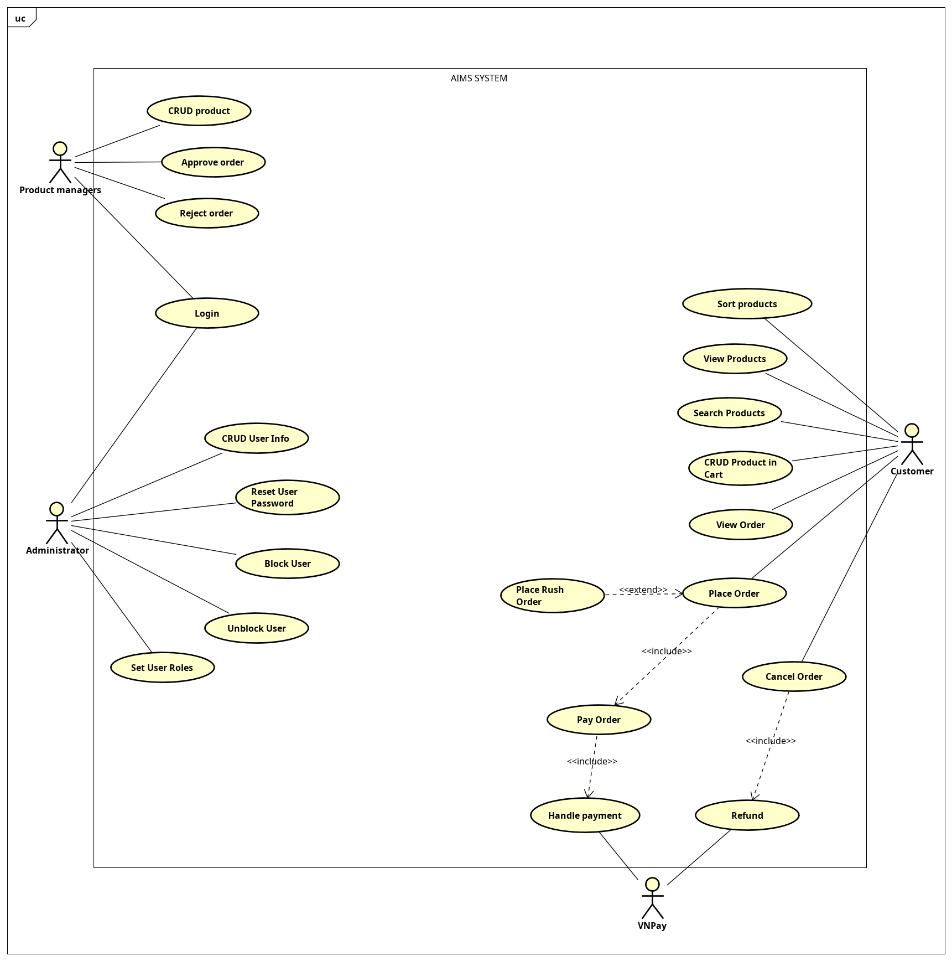

## Business process

The business process will be depicted using activity diagrams (continued). This document will focus solely on the activity diagrams related to the order placement use cases.

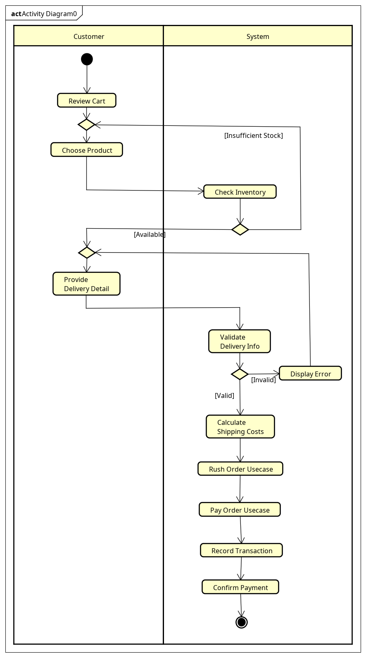

Activity Diagram – Place order

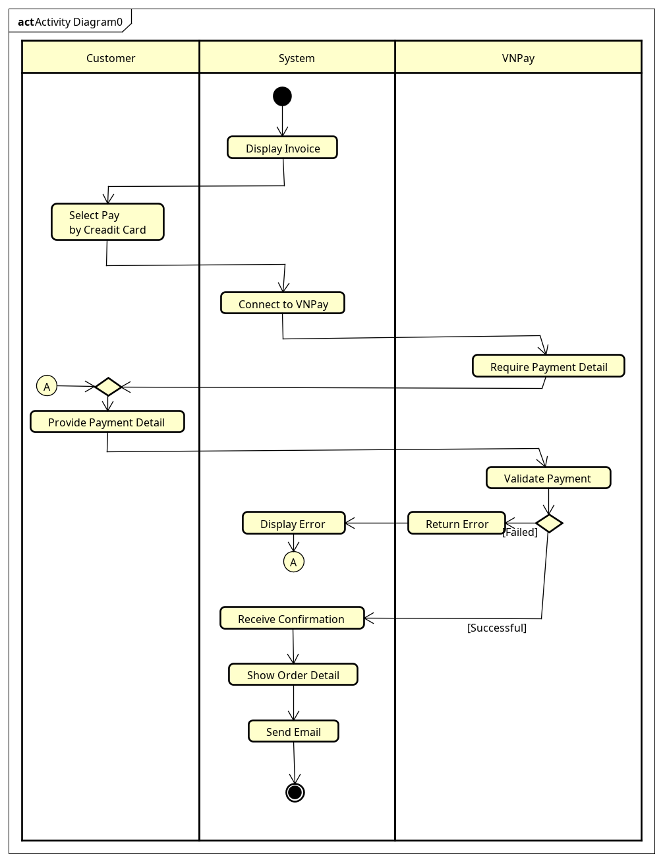

Activity Diagram – Pay order

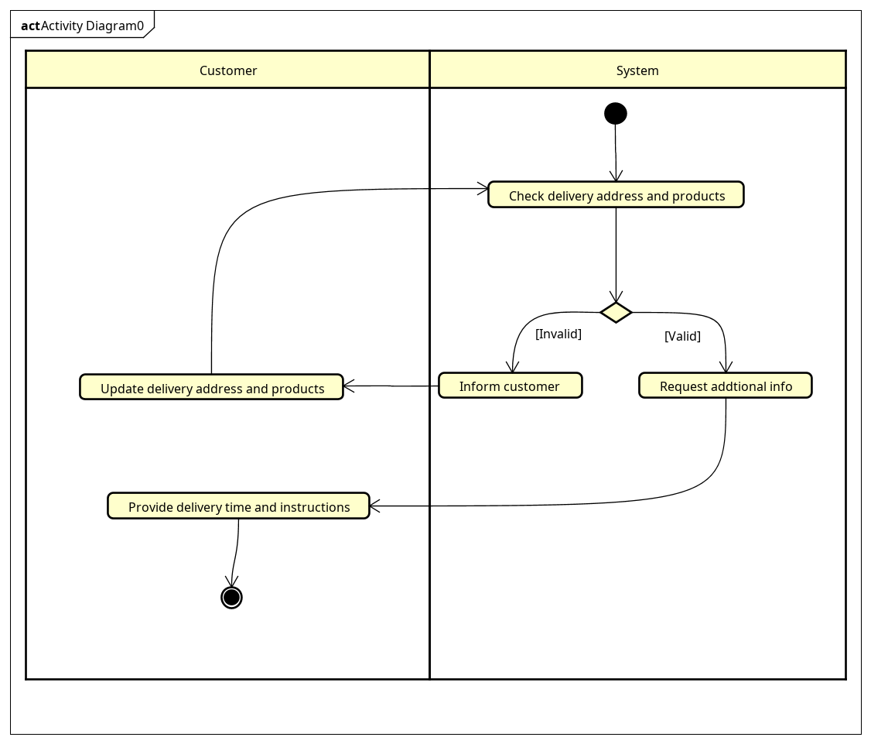

Activity Diagram – Place rush order

# Detailed Requirements

3.1 Product Management

3.1.1 Product Addition

3.1.1.1 The system shall allow product managers to add new products to the inventory. 3.1.1.2 The system shall require the following information for all media products:

* Title
* Category
* Value (excluding VAT)
* Current price (excluding VAT)
* Barcode
* Product description
* Quantity
* Warehouse entry date
* Product dimensions
* Weight

3.1.1.3 The system shall require additional information based on product type:

3.1.1.3.1 For books:

* + Authors
  + Cover type (paperback or hardcover)
  + Publisher
  + Publication date
  + Number of pages (optional)
  + Language (optional)
  + Genre (optional) 3.1.1.3.2 For CDs and LP records:
  + Artists
  + Record label
  + Tracklist
  + Genre
  + Release date (optional) 3.1.1.3.3 For DVDs:
  + Disc type (Blu-ray, HD-DVD)
  + Director
  + Runtime
  + Studio
  + Language
  + Subtitles
  + Release date (optional)
  + Genre (optional)

3.1.1.4 The system shall allow product managers to add only one product at a time. 3.1.1.5 The system shall not limit the number of products that can be added in a day.

3.1.2 Product Editing

3.1.2.1 The system shall allow product managers to edit existing product information. 3.1.2.2 The system shall allow product managers to edit only one product at a time. 3.1.2.3 The system shall limit product managers to updating no more than 30 products per day.

3.1.2.4 The system shall allow product managers to update the price of a product up to twice a day.

3.1.2.5 The system shall ensure that the updated price is between 30% and 150% of the product value.

3.1.3 Product Deletion

3.1.3.1 The system shall allow product managers to delete products from the inventory. 3.1.3.2 The system shall allow product managers to delete up to 10 products at once. 3.1.3.3 The system shall limit product managers to deleting no more than 30 products per day.

3.1.4 Product Viewing

3.1.4.1 The system shall allow product managers to view all product information.

3.1.5 Operation Logging

3.1.5.1 The system shall maintain a history of all product addition, editing, and deletion operations.

3.1.5.2 The system shall notify the product manager of any invalid operations.

3.2 User Management

3.2.1 User Creation

3.2.1.1 The system shall allow administrators to create new user accounts.

3.2.2 User Information Management

3.2.2.1 The system shall allow administrators to view user information.

3.2.2.2 The system shall allow administrators to update user information.

3.2.2.3 The system shall allow administrators to delete user accounts.

3.2.2.4 The system shall allow administrators to reset user passwords.

3.2.3 User Access Control

3.2.3.1 The system shall allow administrators to block user accounts.

3.2.3.2 The system shall allow administrators to unblock user accounts.

3.2.3.3 The system shall allow administrators to set or change user roles.

3.2.3.4 The system shall support multiple roles for each user, including administrator and product manager.

3.2.4 User Authentication

3.2.4.1 The system shall require administrators and product managers to log in to access role-specific features.

3.2.4.2 The system shall allow users to change their passwords.

3.2.5 Notification

3.2.5.1 The system shall automatically send email notifications to users for all administrative actions affecting their accounts.

3.3 Customer Interface

3.3.1 Product Browsing

3.3.1.1 The system shall display a list of 20 random products on each page when the software starts.

3.3.1.2 The system shall allow customers to search for products using product attributes. 3.3.1.3 The system shall display 20 related products on each search result page.

3.3.1.4 The system shall allow customers to sort products by price.

3.3.2 Product Details

3.3.2.1 The system shall allow customers to view detailed information for each product.

3.3.3 Shopping Cart

3.3.3.1 The system shall allow customers to add products to their cart from both the product list and product detail screens.

3.3.3.2 The system shall allow customers to specify the quantity of each product added to the cart.

3.3.3.3 The system shall display the following information when viewing the cart:

* Total price of products (excluding VAT)
* List of products with name, quantity, and price
* Notification of insufficient inventory, if applicable
* Quantity lacking for each product with insufficient inventory

3.3.3.4 The system shall allow customers to remove products from the cart.

3.3.3.5 The system shall allow customers to change the quantity of products in the cart. 3.3.3.6 The system shall maintain only one cart per software session.

3.3.3.7 The system shall empty the cart after a successful order payment.

3.4 Order Processing

3.4.1 Order Placement

3.4.1.1 The system shall not require customers to log in to place an order.

3.4.1.2 The system shall allow customers to review their cart before placing an order.

3.4.1.3 The system shall verify inventory availability each time a customer requests to place an order.

3.4.1.4 The system shall prompt customers to update their cart if inventory is insufficient, displaying available quantities for each affected product.

3.4.2 Delivery Information

3.4.2.1 The system shall require customers to provide the following delivery information:

* Recipient name
* Email
* Phone number
* Province/city for delivery
* Delivery address

3.4.2.2 The system shall validate all required delivery information fields.

3.4.2.3 The system shall calculate and display the delivery fee each time the delivery address is entered or updated.

3.4.3 Rush Order Delivery

3.4.3.1 The system shall offer a rush order delivery option for eligible addresses within the inner city of Hanoi.

3.4.3.2 The system shall verify product eligibility for rush order delivery.

3.4.3.3 The system shall prompt customers to update delivery information or method if rush order delivery is not available for the selected address or products.

3.4.3.4 The system shall request additional information for rush order delivery:

* Delivery time (within a 2-hour timeframe)
* Delivery instructions

3.4.3.5 The system shall calculate and display separate delivery fees for rush order and regular delivery items.

3.4.3.6 The system shall charge an additional 10,000 VND per rush order delivery item.

3.4.4 Payment Processing

3.4.4.1 The system shall display and temporarily save the following invoice information:

* List of products in the cart with quantity and prices
* Total product price (excluding VAT)
* Total product price (including 10% VAT)
* Delivery fee
* Total amount to be paid

3.4.4.2 The system shall allow customers to choose a payment method.

3.4.4.3 The system shall integrate with VNPay for credit card payment processing.

3.4.4.4 The system shall record payment transaction information for successful orders.

3.4.5 Order Confirmation

3.4.5.1 The system shall display the following information after a successful payment:

* Customer name
* Phone number
* Shipping address
* Province
* Total amount paid
* Transaction ID
* Transaction content
* Transaction date and time

3.4.5.2 The system shall set the order status to "pending processing" after successful payment.

3.4.5.3 The system shall send an email to the customer with invoice and payment transaction information.

3.4.6 Order Management

3.4.6.1 The system shall allow customers to view order information using links provided in the confirmation email.

3.4.6.2 The system shall allow customers to cancel orders before they are approved.

3.4.6.3 The system shall process full refunds through VNPay for cancelled orders.

3.4.6.4 The system shall allow product managers to view 30 pending orders per page.

3.4.6.5 The system shall allow product managers to approve or reject orders.

3.4.6.6 The system shall automatically reject orders with insufficient inventory.

3.5 System Performance and Reliability

3.5.1 The system shall support up to 1,000 simultaneous customers without significant performance reduction.

3.5.2 The system shall operate continuously for 300 hours without failure.

3.5.3 The system shall resume normal operation within 1 hour after an incident.

3.5.4 The system shall respond within 2 seconds under normal conditions.

3.5.5 The system shall respond within 5 seconds during peak hours.

3.6 Shipping Fee Calculation

3.6.1 The system shall not apply VAT to shipping fees.

3.6.2 The system shall provide free shipping for orders with a total value exceeding 100,000 VND, up to a maximum of 25,000 VND per order.

3.6.3 The system shall exclude rush order delivery items from the free shipping calculation.

3.6.4 The system shall calculate shipping fees based on the weight of the heaviest item. 3.6.5 The system shall charge 22,000 VND for the first 3kg for deliveries within inner-city Hanoi or Ho Chi Minh City.

3.6.6 The system shall charge 30,000 VND for the first 0.5kg for deliveries elsewhere in Vietnam. 3.6.7 The system shall charge an additional 2,500 VND for every subsequent 0.5kg.

## Use case 1

| **Use Case “Place order”**   1. **Use case code**   UC001   1. **Brief Description**   This use case describes the interaction between the customer and the AIMS software when the customer wishes to place an order.   1. **Actors**   Customer – Initiates the order and provides necessary details for delivery   1. **Preconditions**  * The customer must have selected products in the cart. * The software must have access to the inventory system.  1. **Basic Flow of Events**   1. Customer reviews their cart and selects desired products.  2. Customer initiates the order placement.  3. System checks product availability (check inventory)  4. Customer provides delivery details (name, email, phone, province/city, and address)  5. System calculates and displays shipping costs based on location and product weight.  6. System invokes the "Pay Order" use case.  7. System records transaction details and confirms successful payment   1. **Alternative flows**   **Table N-Alternative flows of events for UC Place order**   | **No** | **Location** | **Condition** | **Action** | **Resume location** | | --- | --- | --- | --- | --- | | 1 | At step 3 | Insufficient stock for one or more items. | 1. System displays a stock shortage notification, indicating available quantities for affected items.  2. Customer modifies their cart.  3. Customer reinitiates the order placement. | Step 3 | | 2 | At step 4 | Customer submits invalid or incomplete delivery information. | 1. System shows an error message highlighting missing or incorrect fields.  2. Customer revises delivery information. | Step 4 | | 3 | At step 4 | The customer chooses rush order delivery option. | 1. System calls the use case "Place Rush Order". | Step 5 |  1. **Input data**   **Table A-Input data of delivery information**   | **No** | **Data fields** | **Description** | **Mandatory** | **Valid condition** | **Example** | | --- | --- | --- | --- | --- | --- | |  | Recipient Name | Name of the person receiving order | Yes | Non-empty | Viet Anh | | 2. | Email | Customer's email address | Yes | Valid email format | vietanh@gmail.com | | 3. | Phone Number | Contact number for delivery | Yes | Valid phone number | 0123456789 | | 4 | Province/City | Delivery location | Yes | Selected from predefined list | Hanoi | | 5 | Delivery Address | Street address for delivery | Yes | Non empty | 123 Main St | | 6 | Credit Card Details | Payment information | Yes | Valid card information as per VNPay requirements | N/A |  1. **Output data**   **Table B-Output data of general information of order and transaction info**   | **No** | **Data fields** | **Description** | **Display format** | **Example** | | --- | --- | --- | --- | --- | | 1 | Customer Name | Name of the customer placing the order | Text | Viet Anh | | 2 | Phone Number | Customer's contact number | Phone number format | 0123456789 | | 3 | Province | Customer's province or city for delivery | Text | Hanoi | | 4 | Address | Customer's full delivery address | Text | 123 Main St | | 5 | Total Amount (Cash) | Total payment amount including VAT and delivery | Currency format | 9,900,000 VND | | 6 | Transaction ID | Unique ID for the payment transaction | Alphanumeric | TX123456789 | | 7 | Transaction Content | Description of the transaction or order purpose | Text | "Order payment for electronics" |  1. **Post conditions**  * The order is successfully placed and payment is processed. * The customer receives an invoice and order confirmation via email. * The system records the transaction and the order is queued for fulfillment. * Update inventory |
| --- | --- | --- | --- | --- | --- | --- | --- | --- | --- | --- | --- | --- | --- | --- | --- | --- | --- | --- | --- | --- | --- | --- | --- | --- | --- | --- | --- | --- | --- | --- | --- | --- | --- | --- | --- | --- | --- | --- | --- | --- | --- | --- | --- | --- | --- | --- | --- | --- | --- | --- | --- | --- | --- | --- | --- | --- | --- | --- | --- | --- | --- | --- | --- | --- | --- | --- | --- | --- | --- | --- | --- | --- | --- | --- | --- | --- | --- | --- | --- | --- | --- | --- | --- | --- | --- | --- | --- | --- | --- | --- | --- | --- | --- | --- | --- | --- | --- | --- | --- | --- | --- | --- |

## Use case 2

| **Use Case “Pay order”**  **1.Use case code**  UC002  **2.Brief Description**  This use case outlines the interaction between the customer, AIMS software, and VNPay when a customer opts to pay for an order via credit card.  **3.Actors**   * Customer: Initiates the payment by providing necessary details. * VNPay: Manages the payment processing through credit cards.   **4.Preconditions**   * The customer has already placed an order and received an invoice. * The VNPay gateway is available for credit card processing.   **5.Basic Flow of Events**   1. The system displays the invoice and temporarily saves it. 2. The customer selects the credit card payment option. 3. The system connects to VNPay for processing the payment. 4. The customer provides the required payment details as prompted by VNPay 5. VNPay validates the payment information and processes the transaction. 6. Upon successful payment, the system receives a confirmation from VNPay. 7. The system returns to the "Place Order" use case.   **6.Alternative flows**  **Table N-Alternative flows of events for UC Place order**   | **No** | **Location** | **Condition** | **Action** | **Resume location** | | --- | --- | --- | --- | --- | | 1 | At step 5 | If the credit card information is invalid or the payment fails | 1. VNPay returns an error message.  2. The software displays an error and prompts the customer to re-enter payment details or choose a different card. | Step 4 |   **7.Input data**  **Table A-Input data of payment information**   | **No** | **Data fields** | **Description** | **Mandatory** | **Valid condition** | **Example** | | --- | --- | --- | --- | --- | --- | | 1. 1 | Credit Card Number | Customer's credit card number | Yes | Valid credit card format | 0123 4567 8910 1112 | | 2 | Expiry Date | Expiration date of the credit card | Yes | Valid future date | "12/29" | | 3 | CVV | Card Verification Value (security code) | Yes | 3-4 digit number | "123" | | 4 | Cardholder Name | Name of the credit card holder | Yes | Not empty | VU VIET ANH |   **8.Output data**  **Table B-Output data of invoice**   | **No** | **Data fields** | **Description** | **Display format** | **Example** | | --- | --- | --- | --- | --- | | 1 | Cart Details | List of selected products and quantities | Table format | See Table 4 | | 2 | Subtotal (before VAT) | Total price before VAT | Currency, comma-separated | “9,900,000” | | 3 | Delivery Fee | Cost of delivery | Currency, comma-separated | "100,000 VND" | | 4 | Total Payment Amount | Total price (including VAT and delivery) | Currency, comma-separated | "Total amount: 10,000,000 VND" | | 5 | Delivery info |  |  | User input in UC “Place order” |   **Table C-Output data of cart details**   | **No** | **Data fields** | **Description** | **Display format** | **Example** | | --- | --- | --- | --- | --- | | 1 | Product Name | Name of the product in the cart | Text | "Phone A" | | 2 | Quantity | Number of units of the product ordered | Numeric | "2" | | 3 | Unit Price | Price per unit of the product | Currency | "10,000,000 VND" |   **9.Post conditions**   * The payment is successfully processed, and the order status is updated to "Paid". * The invoice and payment details are stored in the system. * A confirmation message is displayed to the customer, and a receipt may be sent via email. |
| --- | --- | --- | --- | --- | --- | --- | --- | --- | --- | --- | --- | --- | --- | --- | --- | --- | --- | --- | --- | --- | --- | --- | --- | --- | --- | --- | --- | --- | --- | --- | --- | --- | --- | --- | --- | --- | --- | --- | --- | --- | --- | --- | --- | --- | --- | --- | --- | --- | --- | --- | --- | --- | --- | --- | --- | --- | --- | --- | --- | --- | --- | --- | --- | --- | --- | --- | --- | --- | --- | --- | --- | --- | --- | --- | --- | --- | --- | --- | --- | --- | --- | --- | --- | --- | --- | --- | --- | --- | --- | --- |

## Use case 3

| **Use Case “Place rush order”**   1. **Use case code**   UC003   1. **Brief Description**   This use case describes the interaction between the customer and the AIMS software when the customer wishes to select the rush order delivery option when placing an order.   1. **Actors**   Customer – Initiates the order and provides necessary details for delivery.   1. **Preconditions**  * The customer’s delivery address must be within eligible districts of Hanoi for rush order delivery.  1. **Basic Flow of Events**   1. System verifies if delivery address and products are eligible for expedited shipping.  2. System requests additional expedited shipping information from customer.  3. Place Order use case continues.   1. **Alternative flows**   **Table N-Alternative flows of events for UC Place rush order**   | **No** | **Location** | **Condition** | **Action** | **Resume location** | | --- | --- | --- | --- | --- | | 1 | At step 1 | Selected products or delivery address ineligible for expedited shipping. | 1. System informs customer that expedited shipping is unavailable for some or all items.  2. Customer revises delivery information or product selection. | Step 1 |  1. **Input data**   **Table A-Input data of delivery information**   | **No** | **Data fields** | **Description** | **Mandatory** | **Valid condition** | **Example** | | --- | --- | --- | --- | --- | --- | | 1 | Recipient Name | Name of the person receiving order | Yes | Non-empty | Viet Anh | | 2 | Email | Customer's email address | Yes | Valid email format | vietanh@gmail.com | | 3 | Phone Number | Contact number for delivery | Yes | Valid phone number | 0123456789 | | 4 | Province/City | Delivery location | Yes | Selected from predefined list | Hanoi | | 5 | Delivery Address | Street address for delivery | Yes | Non empty | 123 Main St | | 6 | Credit Card Details | Payment information | Yes | Valid card information as per VNPay requirements | N/A | | 7. | Delivery Time | Time of delivery | Yes | Valid date time format | “Sun Sep 22 2024 23:37:27 GMT+0700 (Indochina Time)” | | 8. | Delivery Instructions | Instructions for delivery | No | Text | “Put the package in front of the door” |  1. **Output data** 2. **Post conditions**  * The selected products or delivery address are eligible for rush order delivery. |
| --- | --- | --- | --- | --- | --- | --- | --- | --- | --- | --- | --- | --- | --- | --- | --- | --- | --- | --- | --- | --- | --- | --- | --- | --- | --- | --- | --- | --- | --- | --- | --- | --- | --- | --- | --- | --- | --- | --- | --- | --- | --- | --- | --- | --- | --- | --- | --- | --- | --- | --- | --- | --- | --- | --- | --- | --- | --- | --- | --- | --- | --- | --- | --- | --- |

# Supplementary specification

## Functionality

* The system must support multiple languages, including Vietnamese and English.
* The system must be capable of generating periodic reports on sales, inventory, and customer purchasing trends.
* The system must have the ability to automatically backup data daily.
* The system must be able to integrate with external accounting and inventory management systems through APIs.

## Usability

* The user interface must adhere to intuitive and user-friendly design principles.
* The system must provide online help and tooltips for complex functions.
* Training time for new employees to use the system should not exceed 4 hours.
* The system must support a dark mode to reduce eye strain for users.

## Reliability

* The system must maintain at least 99.9% uptime in a year.
* The Mean Time Between Failures (MTBF) must be at least 1000 hours.
* The system must be capable of automatic recovery after a failure within 5 minutes.
* The error rate must not exceed 0.1 errors per 1000 lines of code.

## Performance

* The system must handle at least 100 concurrent transactions without performance degradation.
* Response time for search queries must be under 1 second for 95% of cases.
* The system must be capable of handling at least 1 million products in the catalog without affecting performance.
* Page load time must not exceed 3 seconds for 90% of pages.

## Supportability

* The system must be designed with a modular architecture for easy maintenance and upgrades.
* The system must provide detailed logging for all activities to support debugging and troubleshooting.
* The system must support software updates without requiring downtime.
* Technical documentation and source code must be managed using a version control system.

## Other requirements

* Security: The system must comply with PCI DSS standards for handling payment information.
* Privacy: The system must comply with GDPR regulations for protecting users' personal data.
* Scalability: The system must be scalable to support a 200% increase in traffic within 6 months without major architectural changes.
* Compatibility: The system must operate on popular web browsers (Chrome, Firefox, Safari, Edge) and major desktop operating systems (Windows, macOS, Linux).
* Legal Compliance: The system must comply with Vietnamese e-commerce regulations.